Functional Specification Document
Restaurant Chain System

- System Requirement

Mobile Front End
- Apple iPadOs
  - Using iPads.
- Google Android
  - Using Tablets.

Staging
- Application server
  - Red Had JBoss Enterprise Application Platform.
  - Java wrappers using Simple Object Access Protocol (SOAP), to connect between the frontend application and backend system.
  - Including web-based application, access to the application.

Backend
- Microsoft Structured Query Language (SQL)
  - Allow the staging application to store and reads the data.

- High Level Diagram

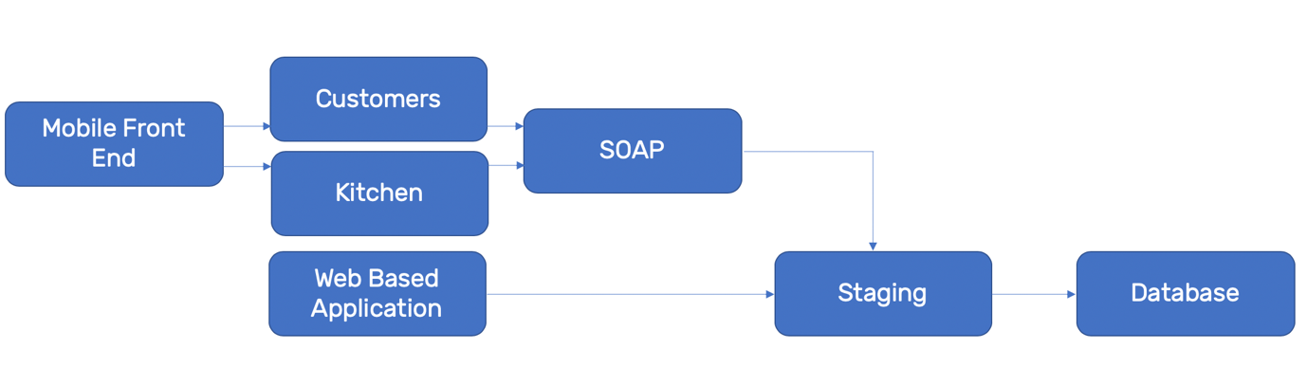
Image 1: High Level Image Illustration

- Application Design

Staging
- Web based application to allow the supervisor of restaurant to enter, the data (ingredients, chef, and price).
- Web based application to allow the supervisor of restaurant to perform audit and accounts for the selected restaurant and branch.
- Simple Object Access Protocol (SOAP), to allow the mobile application to get and send data through database.
- Refer to Supervisor UI.pptx

Mobile Front End
- Enterprise application, used by selected restaurant based, which installed on devices (iPad or Tablets).
- The application will display all the data (ingredients, chef, and price), by the supervisor from the staging.
- The data will be fetched using SOAP through staging to database.
- The ordered menu will be stored using SOAP through staging to database.

Customer
  - Application is design based on the requirements by restaurant from the menus.
  - The menus are will be including the ingredients, chef, and price.
  - The devices will be installed on each table, which will be stored in based real time.
  - Refer to Customer UI.pptx

Kitchen
  - Application will forward the ordered menu to chef at back of kitchen.
  - The details menu customer ordered, will displayed, to allow the chef prepared as requested.
  - Keep track the menu is served to requested table.
  - Kitchen UI.pptx

Database
- Storing all the data from restaurant supervisor, ordered menu, and the served status.

